<https://app.pluralsight.com/library/courses/getting-started-analyzing-network-traffic-wireshark/table-of-contents>

<https://app.pluralsight.com/player?course=wireshark-traffic-analysis-customizing-interface-arp-icmp-dns&author=ross-bagurdes&name=ab9d2ffb-c3f7-49c6-a0df-ab80da67e4d7&clip=0&mode=live>

## Network Protocol

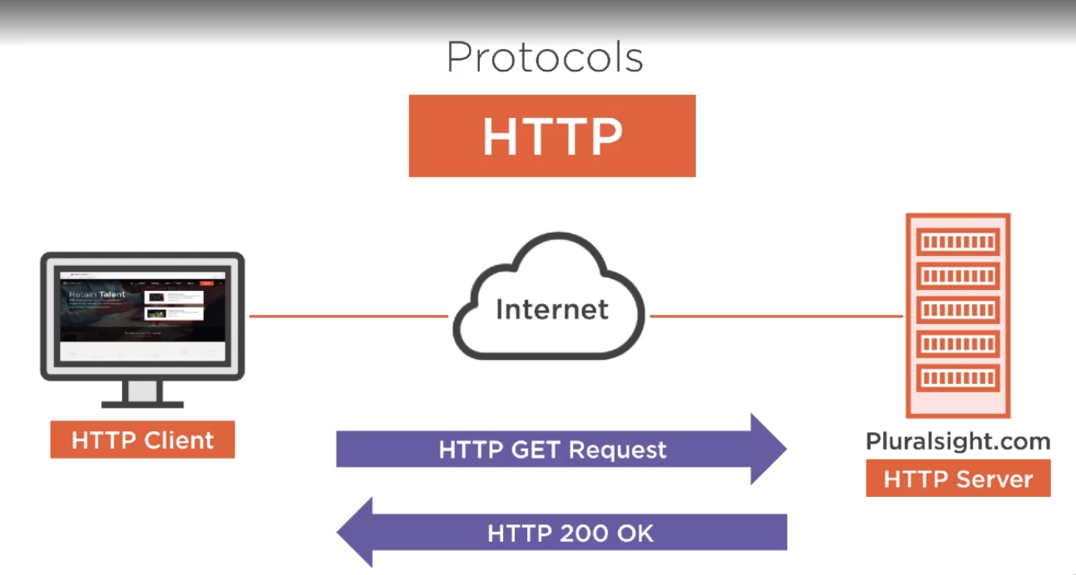

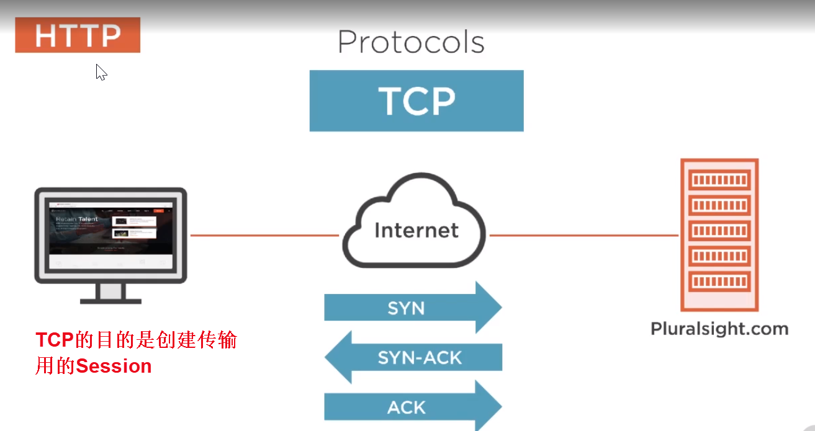

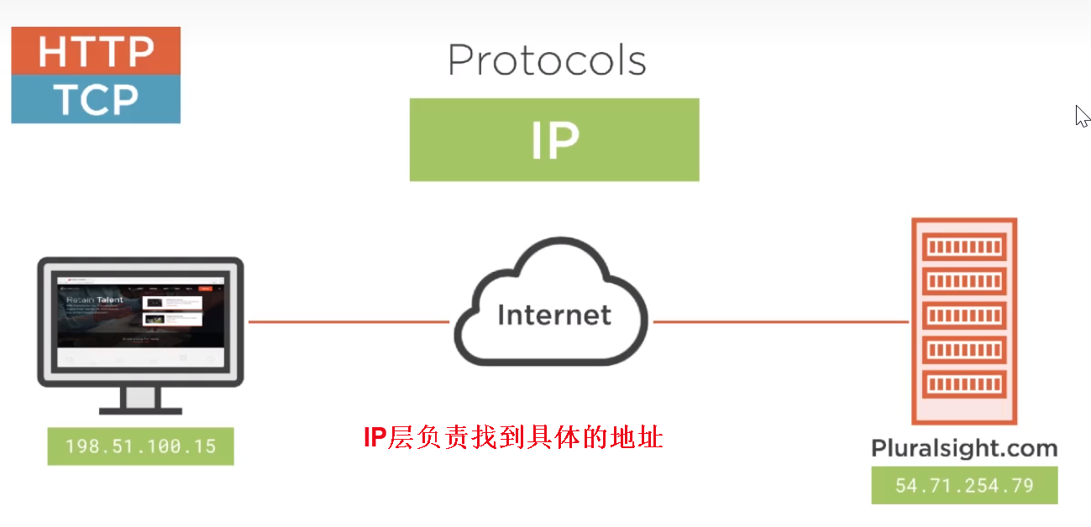

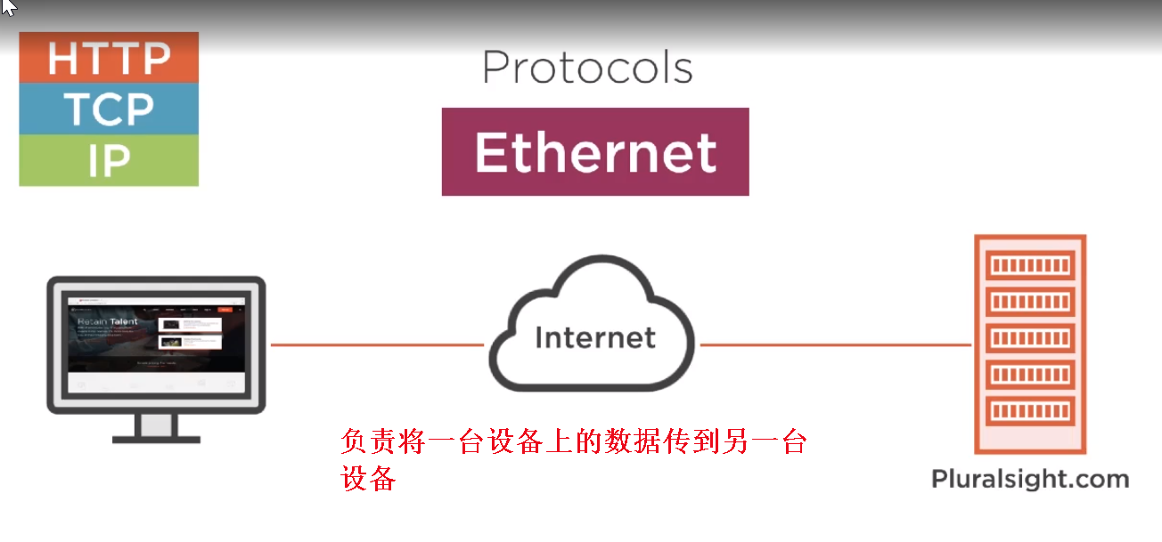

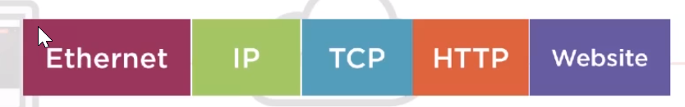

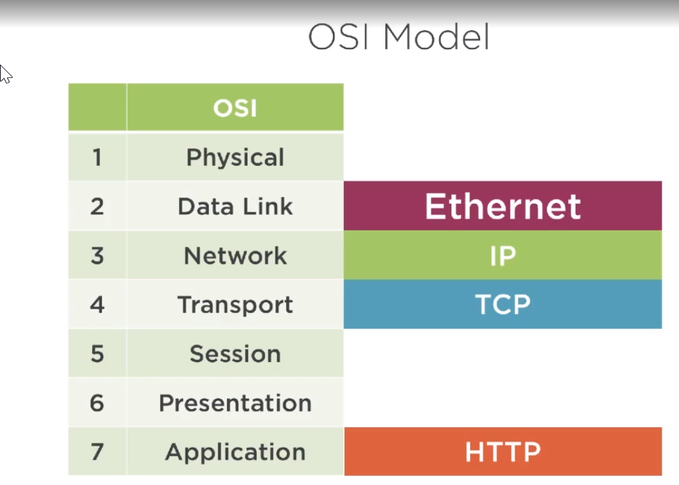

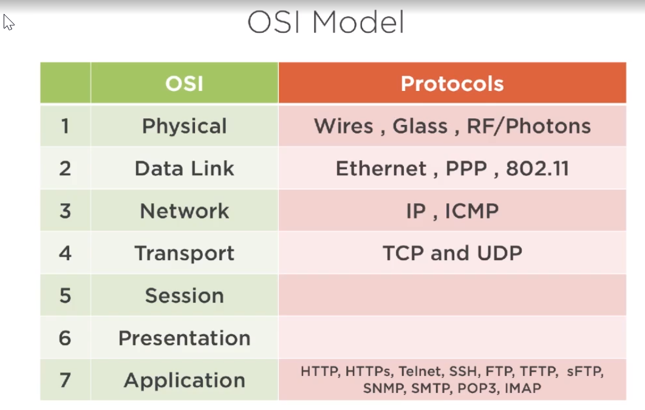

### Wireshark

## Wireshark for tracing URL

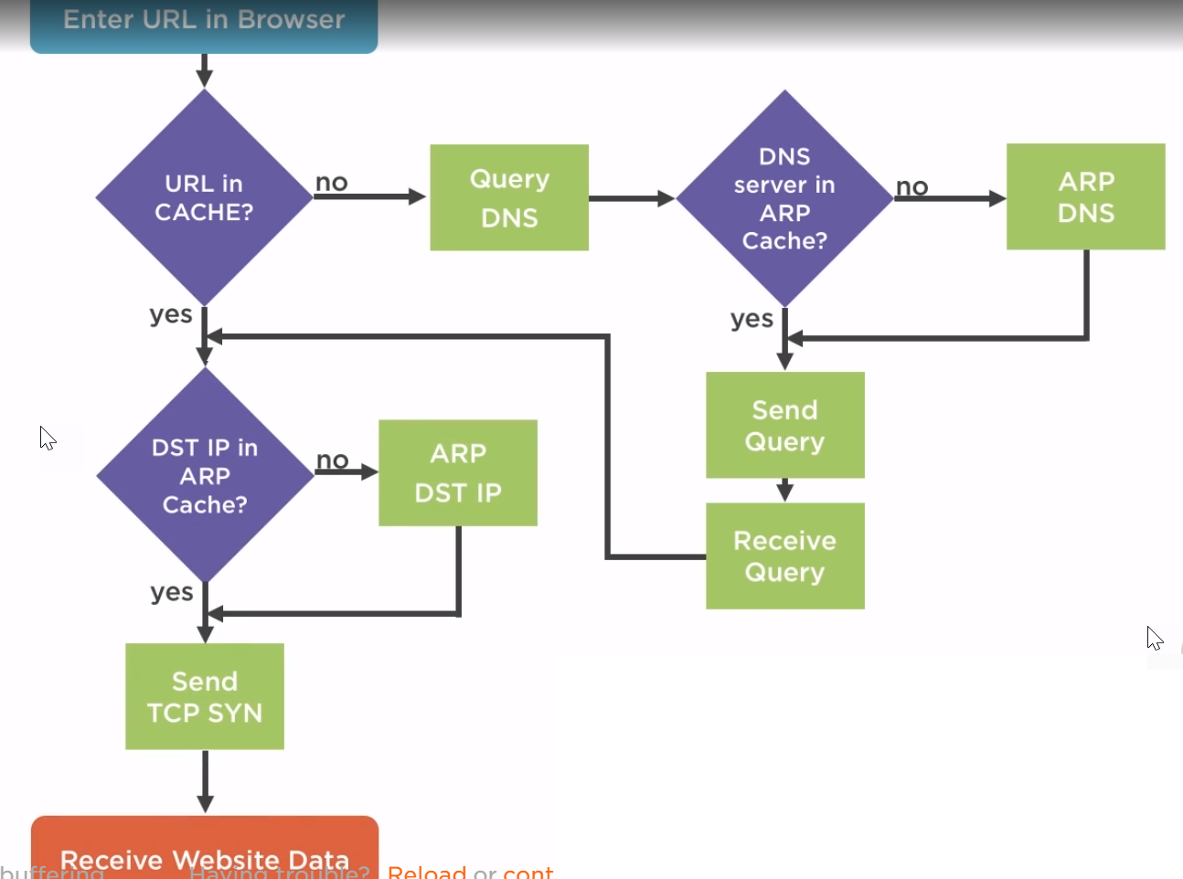

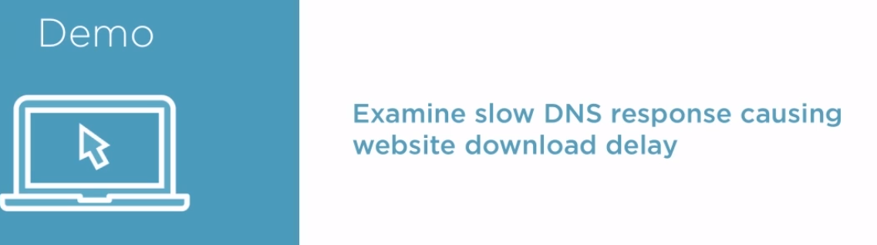

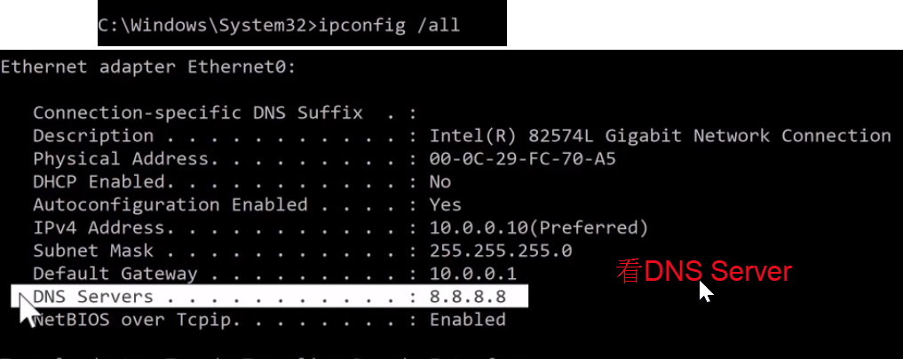

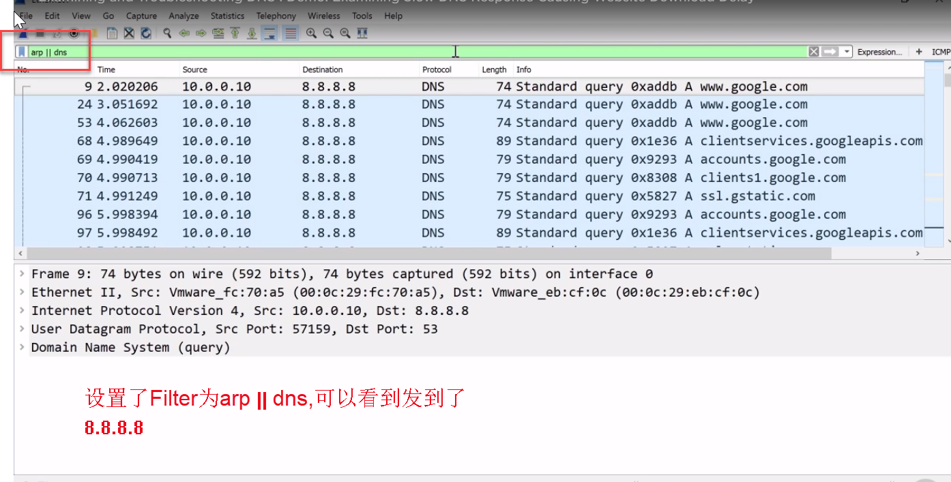

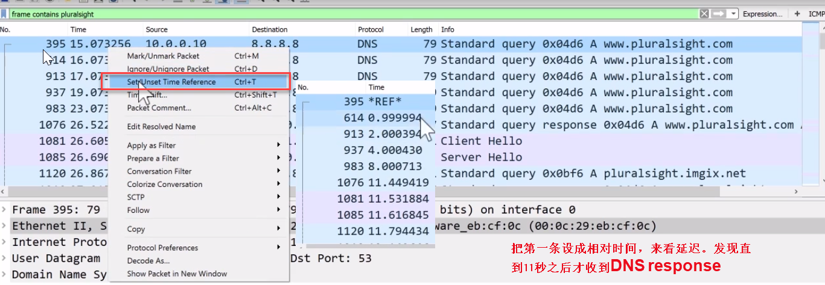

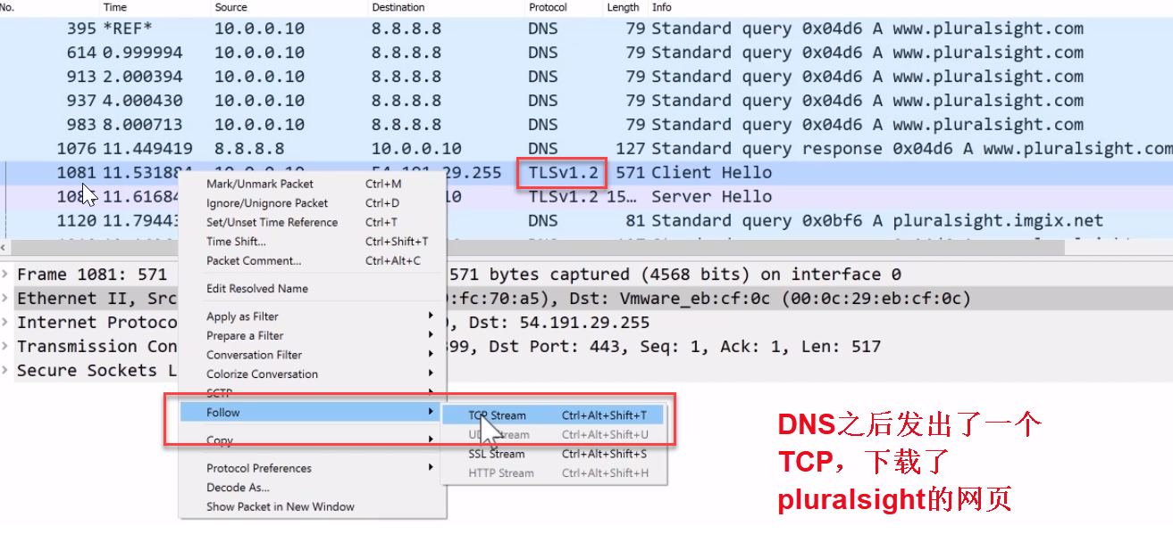

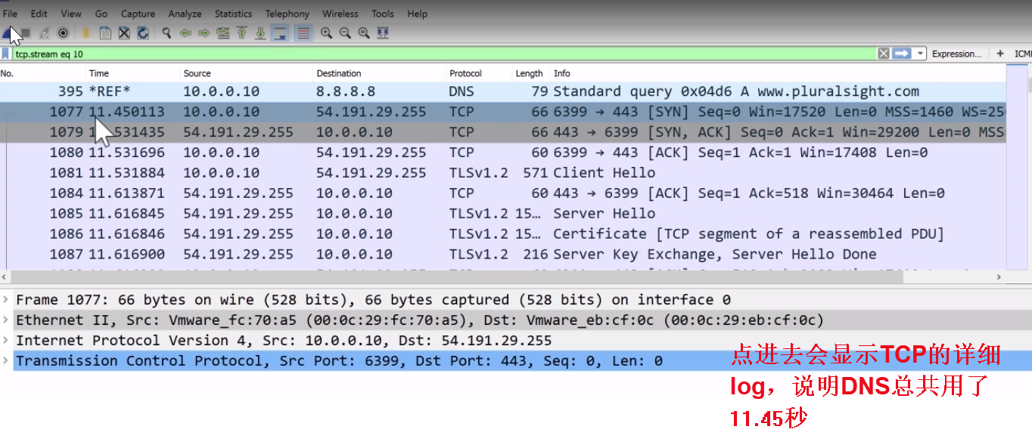

然后换一个DNS Server

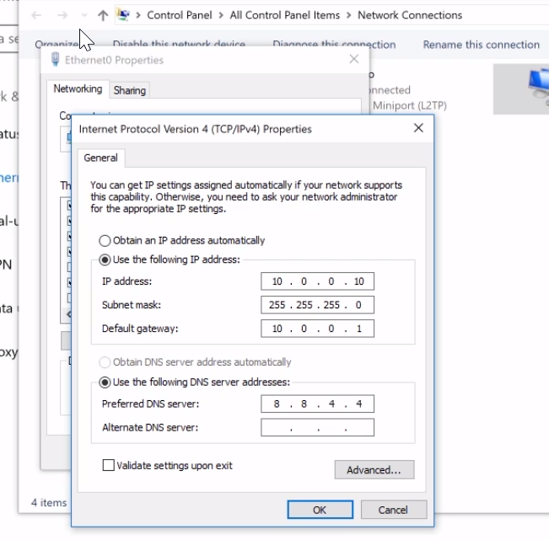

发现这次很快

